Attachment A
Standard E-Mail Stationery for Managing Amber Risk Assessment Strategy

To implement the Amber Risk Assessment Strategy as set out in the Academic Standing, Progression and Exclusion Policy, two sets of standard e-mail stationery have been developed:
- E-mails to make contact with students ‘at risk’ from losing their ‘good academic standing’ (Contact E-mails) and
- E-mails recording management of the risk, after an assessment has been made, and in some cases referral to other services (Risk Management E-mails).

Contact E-mails

- The following e-mail is to be prepared by the School Administrative Officer after the academic/teaching staff member has identified a list of students who have failed to submit their assessment item. For privacy purposes the School Administrative Officer emails the correspondence to the teaching staff member and includes the students’ email addresses in the Bcc as set out in the addressee lines below.

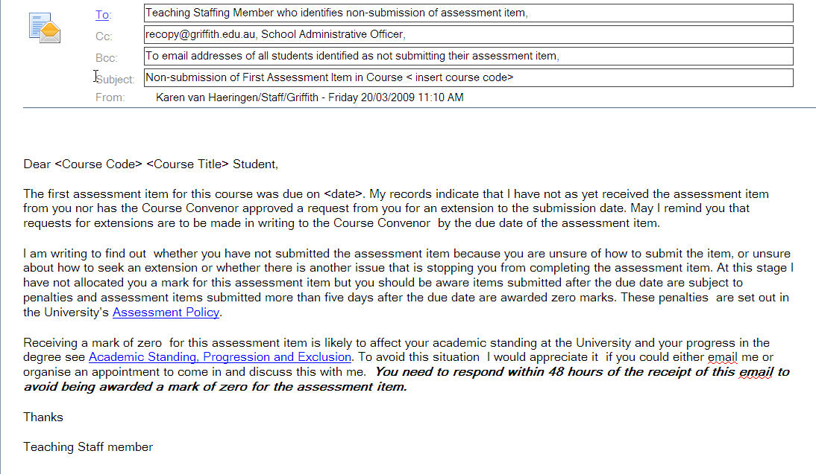

To ensure the email gets to the correct student file, the School Administrative Officer is required to send a copy of the above email but with the following changes:

- The ‘To:’ is to be addressed to Recopy@griffith.edu.au,
- The ‘Bcc:’ is to be cleared of all student email addresses
- At the bottom of the email under the valediction all the student numbers of those students whose email addresses were previously contained in the ‘Bcc:” are to be listed.

Corporate Archives and Record Management Services (CARMS) will receive two copies of the email, one to capture the date and time it was sent to the students and the second to capture the student numbers of those to whom it was sent.

- The following contact e-mail is to be prepared by the School Administrative Officer after the academic/teaching staff member has identified a list of students who did not perform well in their first assessment item. For privacy purposes the School Administrative Officer emails the correspondence to the teaching staff member and includes the students’ email addresses in the Bcc as set out in the addressee lines below.

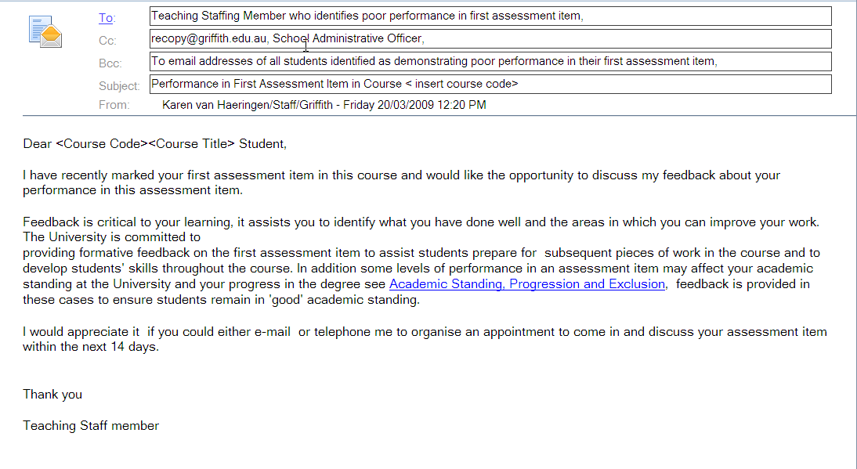

To ensure the email gets to the correct student file, the School Administrative Officer is required to send a copy of the above email but with the following changes:

- The ‘To:’ is to be addressed to Recopy@griffith.edu.au,
- The ‘Bcc:’ is to be cleared of all student email addresses
- At the bottom of the email under the valediction all the student numbers of those students whose email addresses were previously contained in the ‘Bcc:” are to be listed.

Corporate Archives and Record Management Services (CARMS) will receive two copies of the email, one to capture the date and time it was sent and the second to capture the student numbers of those to whom it was sent.

Risk Management E-mails

- The Risk Management E-mails are normally sent to students individually. These e-mails are sent by the academic/ teaching staff member. If there are cases when an academic/teaching staff member proposes to send these e-mails to a group of students, then the e-mail will need to be sent by the School Administrative Officer as per the instructions for the Contact E-mails.

The Risk Management E-mails are sent after contact has been made with the student and an assessment of the action to be taken has been made by the academic/teaching staff member. These e-mails record for the University and the student the action that the student needs to take to reduce the likelihood of losing their ‘good academic standing’. These e-mails are Cc’d to a range of other academic, professional and administrative staff who have roles and responsibilities under the Amber Risk Assessment Strategy.

Attached to the Risk Management E-mails is a referral form for Learning Services which is to be signed off by Learning Services and returned by the student to Student Administration, so it can be scanned onto the student file as a record.

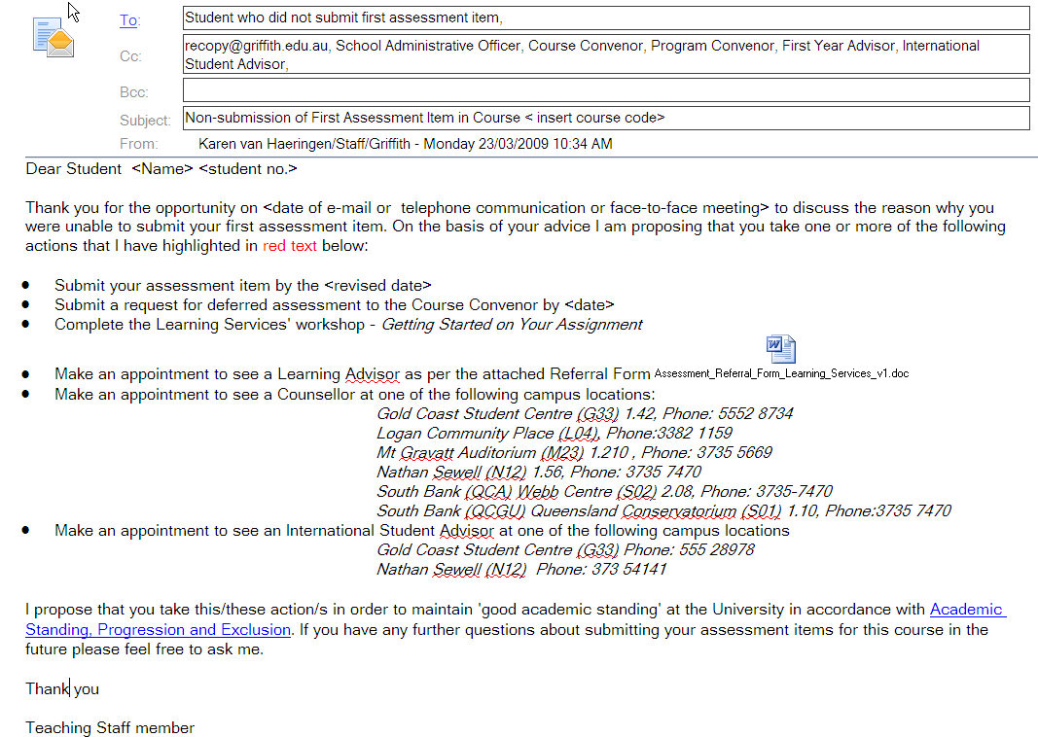
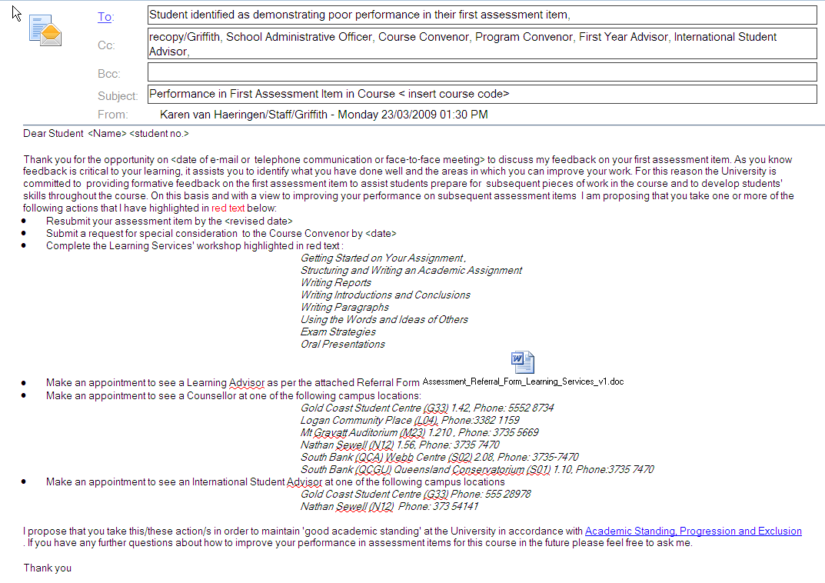



Attachment B Learning Services Referral Form – Assessment Issues
This form is intended to be used by academic staff for purposes of referring students to Learning Services for matters relating to non-submission of and performance issues in their first assessment item as outlined in the Policy on Academic Standing, Progression and Exclusion. Learning Services will deal directly with the referred student who will need to take responsibility for: (a) contacting Learning Services to make an appointment time for the consultation; (b) presenting this form for signature at the time of the consultation; and (c) returning the signed form to Student Administration.

1. STUDENT PERSONAL DETAILS
Griffith Identification number: |  | Name: |  | Phone:
 |  | Family name:
 |  | First name: |  | Email:

Course code: |  | Course title:

2. REFERRING STAFF MEMBER DETAILS
- Teaching Team Member: ___________________________________________________ (name) ___________________ (phone)
- Course Convenor: __________________________________________________ (name) ____________________ (phone)
- Other: _____________________ (position title ) ____________________________ (name) ____________________ (phone)

3. REASON FOR REFERRAL

Referring staff member to provide details regarding nature of assessment concern and type of assistance required.

4. LEARNING SERVICES CONFIRMATION
I confirm that the above student has sought study skills advice from Learning Services related to this assessment matter.
Learning Services Staff Name: _________________________ Position: ___________________________
Signature: _______________________________________ Date: ______________________________

GUIDELINES FOR STUDENTS
- Telephone Learning Service to make an appointment with a Learning Adviser.
◻ Gold Coast 555 28109 ◻ Logan 338 21108 ◻ Mt Gravatt 373 55778 ◻Nathan/ South Bank 373 56452
- Present this form for signature at your appointment.
- Return the signed form to one of the drop off boxes available in all student centres.

